PRACTICAL – 2

PROGRAM -1

AIM- TO CONVERT THE TEMPERATURE FROM Degree CELSIUS TO Degree FAHRENHEIT [INPUT FROM USER]

CODE-

#include<stdio.h>

void main()

{

printf("\n HARSH D \n");

int a;

printf("Enter Temperature in Celsius = ");

scanf("%d",&a);

float fahrenheit = (a * 9.0 / 5.0) + 32.0;

printf("Temperature In Fahrenheit = %f",fahrenheit);

}

OUTPUT:-

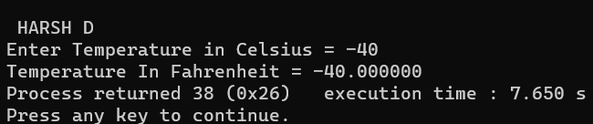

AIM- TO CONVERT THE TEMPERATURE FROM Degree FAHRENHEIT TO Degree CELSIUS [INPUT FROM USER]

CODE-

#include<stdio.h>

int main()

{

float f,result;

printf("\n HARSH D \n");

printf("Enter the temperature in Fahrenheit = ");

scanf("%f",&f);

result=(f - 32)*5/9;

printf("Fahrenheit: %.3f converts to %.3fC",f,result);

return 0;

}

OUTPUT-

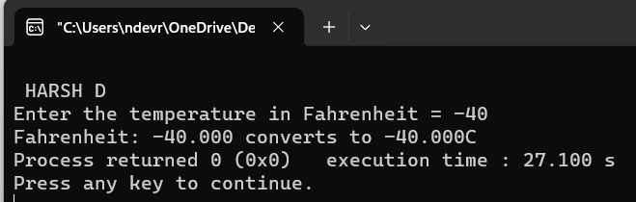

PROGRAM -2

AIM- WACP TO SWAP TWO NUMBERS USING THIRD VARIABLE

CODE- OUTPUT-

|  |
| --- |
| #include<stdio.h>  void main()  {  int a=5;  int b=6;  int c;  c=a;  a=b;  b=c;  printf("\n a=5 \n b=6 ");  printf("\n After Swapping :");  printf("\n a=%d \n b=%d",a,b);  } |

AIM- WACP TO SWAP TWO NUMBERS WITHOUT USING THIRD VARIABLE

CODE- OUTPUT-

|  |
| --- |
| #include<stdio.h>  void main()  {  int a=5;  int b=6;  a=a+b;  b=a-b;  a=a-b;  printf("\n a=5 \n b=6 ");  printf("\n After Swapping :");  printf("\n a=%d \n b=%d",a,b);  } |

PROGRAM -3

AIM- WACP TO FIND SIMPLE INTREST WITH INPUT FROM USER

CODE-

|  |
| --- |
| #include<stdio.h>  int main()  {  float principal, rate;  int time;  float simple_interest;  printf("Enter principal amount: ");  scanf("%f", &principal);  printf("Enter rate of interest: ");  scanf("%f", &rate);  printf("Enter time period: ");  scanf("%d", &time);  simple_interest = (principal * rate * time) / 100;  printf("Simple Interest: %f", simple_interest);  return 0;  } |

OUTPUT-

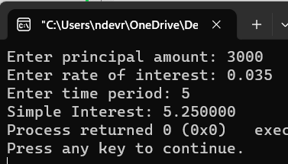

AIM- WACP TO FIND COPMPUND INTREST WITH INPUT FROM USER

CODE- OUTPUT-

|  |
| --- |
| #include<stdio.h>  #include<math.h>  int main()  {  float principal, rate;  int time;  float compound_interest;  printf("Enter principal amount: ");  scanf("%f", &principal);  printf("Enter rate of interest: ");  scanf("%f", &rate);  printf("Enter time period: ");  scanf("%d", &time);  compound_interest = principal * pow((1 + rate / 100), time) - principal;  printf("Compound Interest: %f", compound_interest);  return 0;  } |

PROGRAM -4

AIM- WACP to find sum of all integers greater than 100 & less than 200 and are divisible by 5.

CODE-

|  |  |
| --- | --- |
| #include <stdio.h>  int main()  {  int i;  printf("Numbers from 101 to 199 that are divisible by 5: \n");  for(i=101; i<200; i++)  {  if(i%5==0) OUTPUT:-   |  | | --- | |  |   {  printf("\n%d",i);  }  }  printf("\n");  int sum=0;  for(i=101; i<200; i++)  {  if(i%5==0)  {  sum += i;  }  }  printf("The sum : %d \n", sum);  return 0;  } |

PROGRAM -5

AIM- WACP to find The distance between two cities (In KM) is input through key board. Write a program to convert and print this distance in meters, feet, inches & centimeters.

CODE-

|  |
| --- |
| #include<stdio.h>  int main()  {  int Km,m;  printf("Enter the Distance in Km = ");  scanf("%d",&Km);  m= Km * 1000;  printf("\n The distance In Meter = %d",m);  int Cm;  Cm = m * 100;  printf("\n The distance In Centimeter = %d",Cm);  float Feet;  Feet = m * 3.280 ;  printf("\n The distance In Feet = %.3f",Feet);  int Inches;  Inches = Feet * 12;  printf("\n The distance In Inches = %d",Inches);  printf("\n");  } |

|  |
| --- |
| Output:- |